URL | Screenshot for 360 Vacation center
https://laurenconrad.com/blog/2013/06/summer-travel-101-how-to-pack-like-a-pro-tips-lauren-conrad-popsugar-june-2013/ | 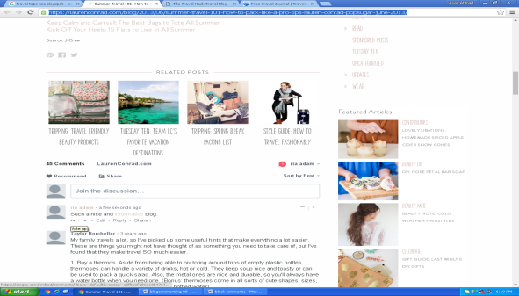
http://thetravelhack.com/welcome/welcome-travel-hack/ | 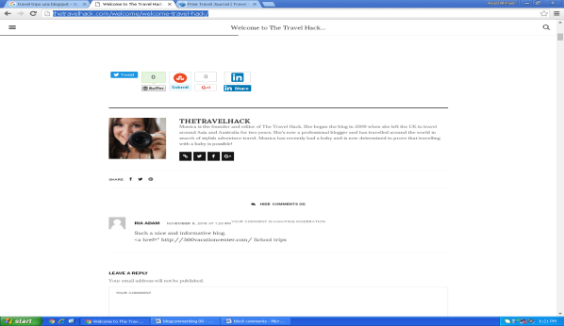
http://www.butterfield.com/blog/2016/11/02/deep-brief-history-colombia/#comment-506438 | 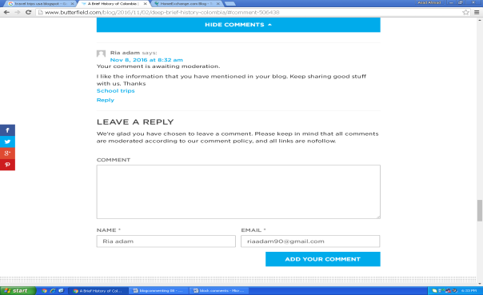
http://blog.homeexchange.com/blog/meet-a-member/further-reflections-on-retirement-and-home-exchange/6203/#comment-135359 | 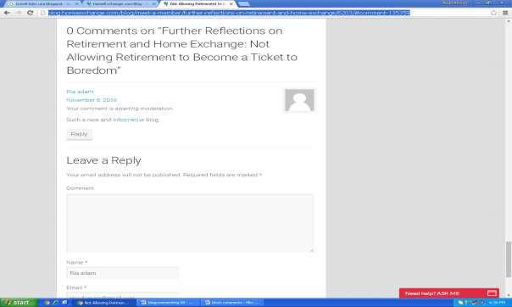
http://blog.feedspot.com/top-100-travel-blogs-to-check-out-in-2016/#comment-7590 | 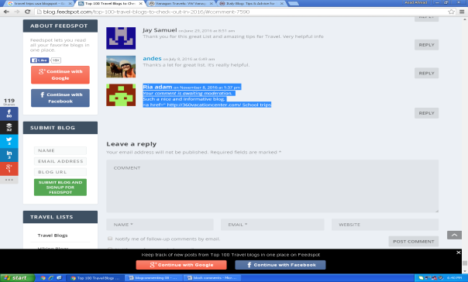
http://www.vanagontravels.com/2016/07/vanagon-road-trip-erving-state-forest.html?showComment=1478612480951#c355294879415717791 | 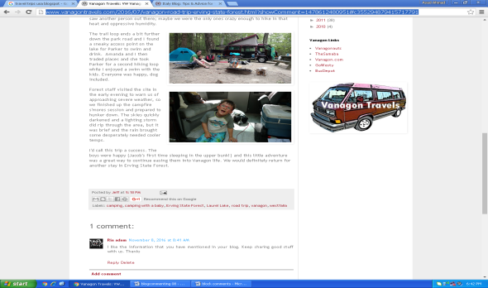
https://www.walksofitaly.com/blog/umbria/visit-assisi-italy-attractions#comment-380192 | 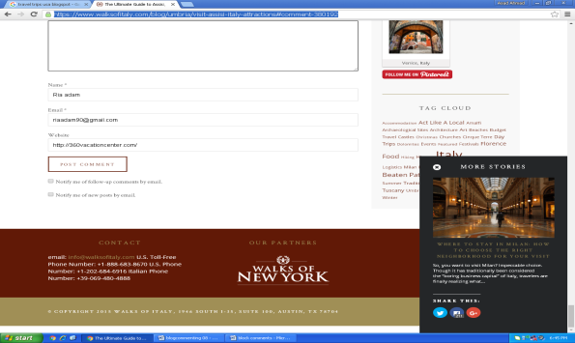
http://fittwotravel.com/2016/10/17/travel-hack-cheap-flights/#comment-2433 | 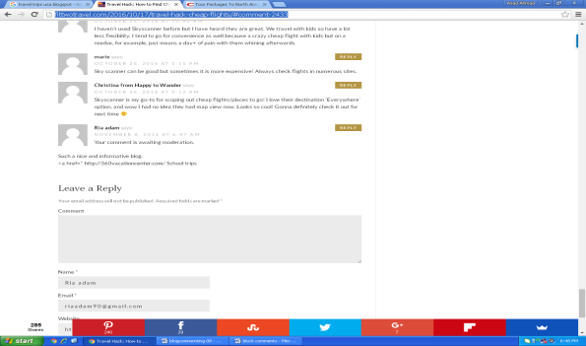
http://www.tripbase.com/blog/10-essential-tips-for-israel-travel/#comment-447493 | 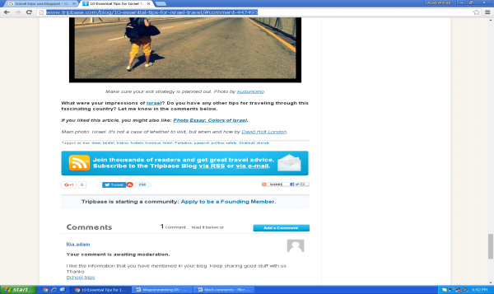
http://www.ontheluce.com/2013/05/15/tips-for-roadtripping-the-sw-usa-on-a-budget/#comment-156806 | 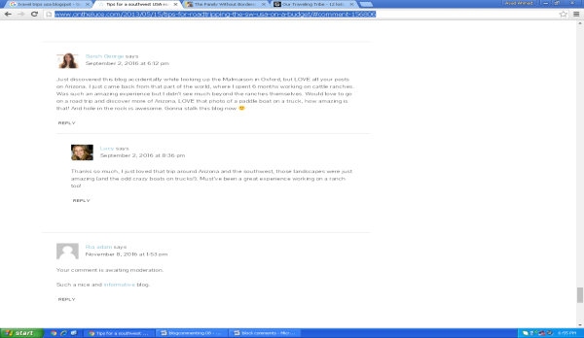
http://thefamilywithoutborders.com/a-little-heaven-saint-marie-island-madagascar-2016-10-09/comment-page-1/#comment-54067 | 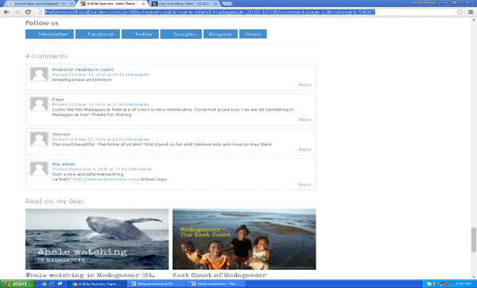
http://www.neverendingfootsteps.com/2013/12/07/road-trip-itinerary-us-southwest/#comment-305628 | 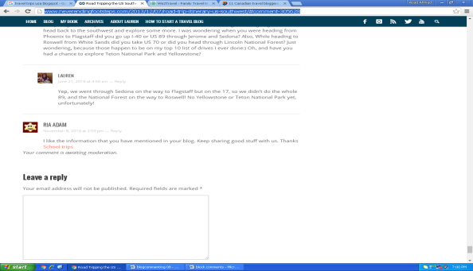
http://we3travel.com/thanksgiving-at-universal-orlando/#more-16629 | 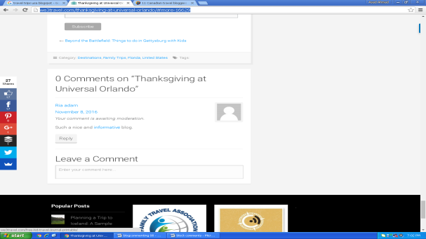
https://seniornomads.blogspot.com/2016/10/armenia-monastaries-and-stolen-mountains.html?showComment=1478613879834#c1111042787515333910 | 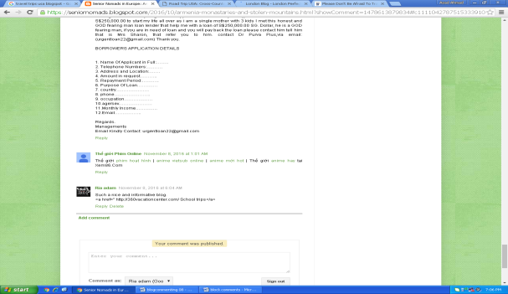
http://www.wanderingearl.com/please-dont-be-afraid-to-travel-on-your-own/comment-page-6/#comment-7937230 | 